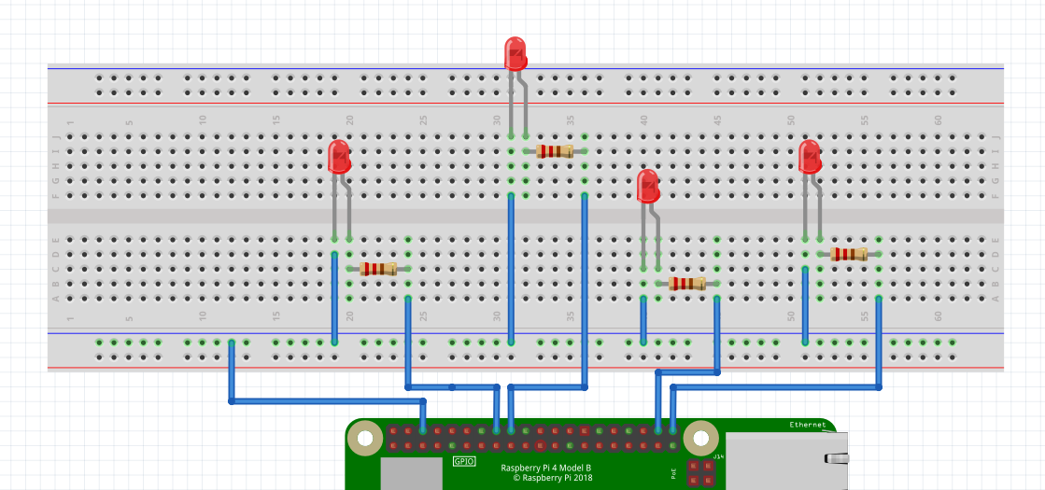

SIMULATION OF CONTROL OF ROBOTIC CAR USING LEDs

**DOWN -KEY**

**RIGHT -KEY**

**LEFT -KEY**

**UP -KEY**

**GND**

**PIN 21**

**PIN 20**

**PIN 23**

**PIN 24**

PROGRAM : cursescontrollingLED.py

modify cursescontrollingLED.py as follows:

Instead of using the arrow keys, use W=UP, D=RIGHT, Z=DOWN, A=LEFT and S for Exit

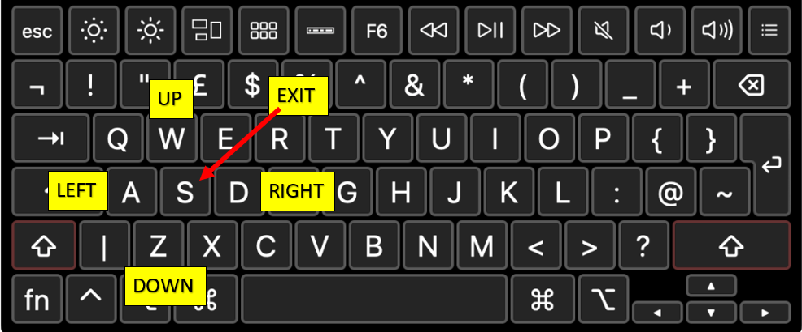

Proceed to cursingrobby.py

**Exercise 1. Make Robot do a square when P key is pressed**

**Exercise 2. Make Robot**

Move forward for 5 seconds

Turn Left and move for 5 seconds

Turn Right and move for 5 seconds

Then Move backward

Then Stop